# Around the World with the ‘Truck Patriot’: Memetization and the Circulation of Laughter in the 2022 Post-Election Period in Brazil

### Viviane Borelli[1] and Isabel Löfgren[2]

​​’Laughter is a philosophy. Often, laughter is salvation. And in constitutional politics, at least, laughter is an opinion.’ — Eça de Queiroz, As Farpas[3]

## Prelude to a meme

Brazil experienced a historic moment on October 30, 2022, when Luiz Inácio Lula da Silva (Lula) was elected President of Brazil. For the first time in recent Brazilian history, a sitting president was not re-elected for a second term. Refusing to recognize defeat, Jair Bolsonaro hid in the presidential official residence, retreated into silence, and left the public scene for two days. In the meantime, moments after the election results were announced, Bolsonaro’s disgruntled supporters mobilized for anti-democratic and coup-related actions across the country resulting in the almost immediate blockage of highways by truck drivers and occupations in front of army barracks by fanatic militants. In addition, rumors about a military intervention to step in within 72 hours to keep Bolsonaro in power and annul election results spread very quickly.[4] This type of networked social and political mobilization aided by a symbolic apparatus financed by businessmen, politicians, and other social groups,[5] would culminate months later in the attempted coup of January 8, 2023, in Brasilia.

Two days after the election, on November 1, Bolsonaro finally broke his silence. In a much-awaited press conference, he assuaged his supporters’ dissatisfaction with his defeat by alluding to electoral misconduct by authorities, vaguely encouraging peaceful demonstrations, and deflecting any potential accusations of violence incitement by attacking the left. In a speech, he declared that

(...) The current popular [Bolsonarist] movements are the result of indignation and a sense of injustice regarding how the electoral process unfolded. Peaceful demonstrations will always be welcome, but our methods cannot be those of the left, which has consistently harmed the population, such as property invasions, destruction of heritage, and restrictions on the right to come and go.[6]

Despite the gravity of the protests, it was during this interim period between Lula's victory and Bolsonaro's return to the public scene that an opportunity for a critical and humorous resistance arose among Lula's supporters in the festive spirit of the victory. However, before we delve into what became the most acclaimed meme of 2022, it is necessary to understand the media context of that moment to grasp the pivotal role of memes in this turbulent period.

One of the most striking features of Jair Bolsonaro's government (2019-2022) was the construction of a sophisticated social media and media apparatus for organizing and mobilizing supporters. This, in turn, was supported by an institutional apparatus known as ‘digital militias’ that fostered an industry of fake news and disinformation as a government strategy that helped consolidate the far-right social movement in Brazil.[7] As a result, anti-Bolsonaro movements were forced into a defensive position until the late 2022 general elections.[8]

During the presidential campaign, some high-profile Lula supporters such as Congressman André Janones and digital influencer Felipe Neto used their Twitter profiles to take down Bolsonaro’s fake news machinery with memes, short videos, sensationalist news reports, live sendings, and more, to reverse the political situation.[9] In addition, Lula’s leftist Workers' Party (PT) established an innovative media strategy by creating a legal apparatus against electoral crimes committed by Bolsonaro, whose campaign was largely based on fake news designed to delegitimize election results and defame his political opponents. Some of these legal actions resulted in media restrictions and other legal measures by the Superior Electoral Court (TSE) to thwart Bolsonaro’s strategies to attack the electoral system’s legitimacy.[10] The leftist campaign strategy was successful insofar as it instilled a sense of confidence and unity among Lula’s supporters, as well as turning the legal apparatus in Lula’s favor eventually leading to his victory. However, even with significant efforts by authorities and civil society to combat the Bolsonarist fake news machinery during the campaign, it was not possible to control the proliferation of messages among radical Bolsonarist groups in the aftermath of the election.[11]

## The Road Blockades and the Emergence of the 'Truck Patriot' meme

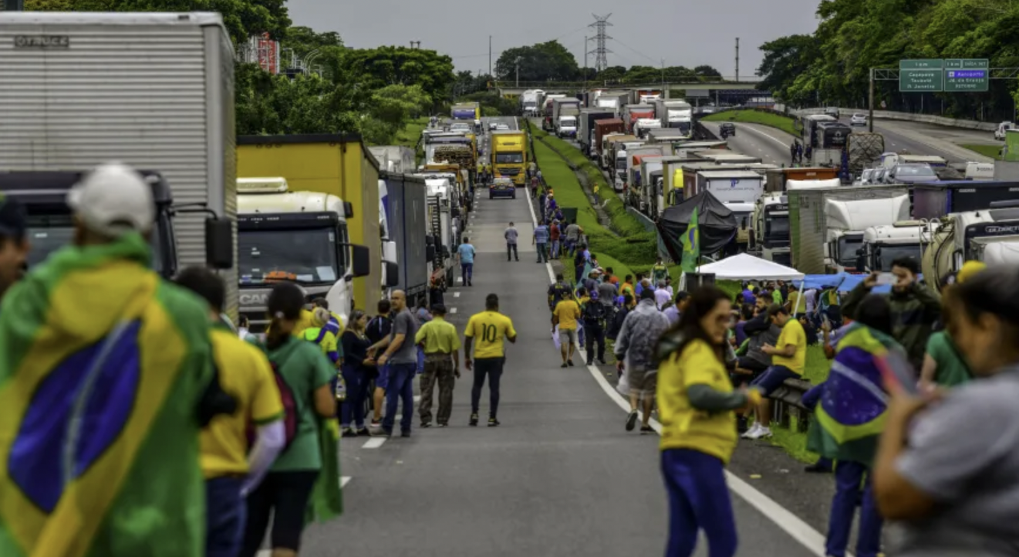

Figure 1: Truckers' blockade on Presidente Dutra highway outside the city of São Paulo,Brazil. Credit: Lucas Lacaz Ruiz/*Estadão Conteúdo*.

Soon after Bolsonaro’s defeat was announced in the late evening of October 30, 2022, Bolsonaro supporters took to the streets claiming that the elections were rigged. They demanded the investigation of electronic polling stations and a ‘military intervention’ to delegitimize the election.[12] Bolsonarist truck drivers blocked traffic on highways while others camped in front of army barracks all over the country (Figure 1).[13] It is now known that the truckers were supported by some members of the Federal Highway Police (PRF),[14] but at the time, it did not prevent demonstrators from unlawfully blocking the roads or removing them from specific locations.[15] As a result of this coordinated action by protesters financed in part by businessmen from the agribusiness and cargo transport sectors, and with the veiled consent of authorities like the PRF, the transportation system fell into chaos, and deliveries of goods nearly halted in Brazil.[16]

The incitement for mobilization for the protests occurred largely through the widespread false information in messages on Twitter, Facebook, Instagram, and TikTok, but especially in radical Bolsonarist groups on WhatsApp and Telegram. These platforms, previously used by Bolsonaro supporters for various national-scale mobilizations during his government, featured images, videos, and memes supporting truckers, as well as calls for various protest actions accompanying the blockades.[17]

In these gatherings, a distinctive visuality emerged: people wearing yellow football jerseys and waving flags, and all sorts of nationalistic paraphernalia in yellow and green, the colors of the Brazilian national flag (Figure 1) – a visual identity that had already been institutionalized within Bolsonarism since the 2018 presidential elections. Also known as ‘Patriots’, these green-and-yellow-clad protesters became the symbols of devotion and sacrifice to Bolsonaro and his government, who often referred to the then-president as *The Myth*.

On the internet, a curious memetic phenomenon involving a Bolsonarist ‘Patriot’ marked the history of the Brazilian internet: the ‘Truck Patriot’ meme (in Portuguese, ‘O Patriota do Caminhão*’*). We refer to this event as a *memetivistic turn* – or activism through memes – in Brazilian internet culture and in the Brazilian political landscape. This phenomenon helped wrest media dominance from the Bolsonarists in the unstable period that followed but also widened the abyss between Lula’s and Bolsonaro’s supporters in the coming months.

## A Ready-made Meme

The story of how the meme started is as one-of-a-kind as the buzz it created, making it one of the top and most widely discussed memes in the media in 2022, that ‘made Brazil smile’.[18] On November 2, 2022, the third day of trucker protests and roadblocks, 41-year-old businessman Júnior César Peixoto from Caruaru, in northeastern Brazil, went to a blockage point on a federal highway to deliver food to protesters. At one point, he noticed that a dissenting truck driver had broken through the blockade and then attempted to stop the truck while in motion. This is when the unusual scene unfolded: the man, dressed in a yellow shirt and Brazil cap, climbed onto the front part of the truck’s cabin, cruised at high speed, and clung to the windshield without letting go for 10 kilometers. This unusual ride allowed many passers-by and the truck driver himself to capture the scene on video.

## 

Figure 2: News report showing the Bolsonaro supporter from inside the truck, filmed by the driver. Source: *UOL*, Youtube.[19]

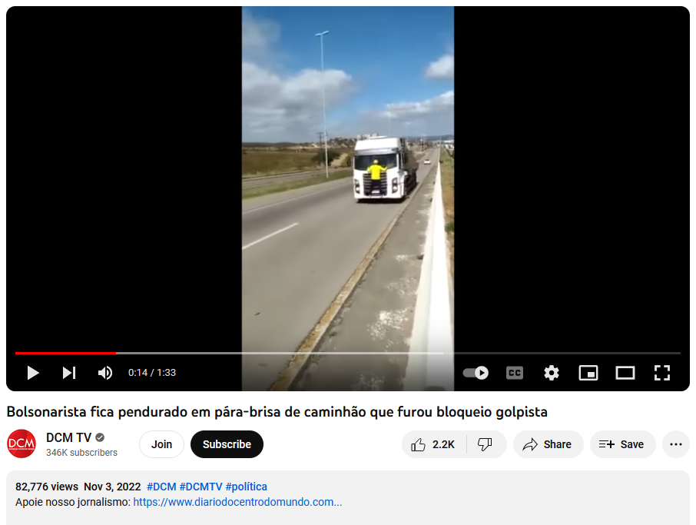

Figure 3: ‘Bolsonarist stuck to the windshield of a truck that broke through coup-related road blockade’. Video still. Source: *DCM TV*, Youtube 3 November, 2022.[20]

This is a unique case where the meme is born ready in the face of the unexpected and unexplainable because the ‘Patriot’ from Caruaru achieved the improbable: he clung to the front of the truck for almost 10 minutes in dangerous conditions against any traffic rules and was captured by dozens of mobile cameras in photos and videos on its path. The images, which initially went viral in a video from November 2, 2022, were captured from two angles: from inside the cabin by the truck's driver that shows the protester’s face (Figure 2), and by passers-by and parked trucks on the highway with a view of the moving truck and the ‘Patriot’ hanging in front of the vehicle (Figure 3). The figure came to be known as the ‘Truck Patriot’.

As soon as the first videos of the ‘Truck Patriot’ were released to the public, the original videos (Figure 2) quickly became newsworthy in mainstream media outlets and on messaging apps and social media platforms. Since WhatsApp is used by 54% of Brazilians, a significant portion of the population very likely became aware of the videos through the messaging app.[21]

After the initial circulation of this material reporting the incident, anti-Bolsonaro audiences immediately repurposed these scenes into images, memes, collages, mashups, montages, parodies, and other viral digital formats. Online news outlets first reported the incident as the 'man hanging onto a truck', and later as ‘the Bolsonaro supporter on the truck’. However, after going viral the memes soon came to be known as ‘the Truck Patriot,' and in international meme repositories as simply 'Truck Patriot’.[22]

A search for the hashtag *#truckpatriot* yielded more than 1,000 results of memes and videos on Instagram, and approximately 3,000 results including text posts, images, and videos on Twitter, mostly between November 2 and 10, 2022, followed by numerous iterations in the months that followed. On YouTube, the ‘Truck Patriot’ appears in video formats such as video clips, montages, reportage, comedy sketches, and more. The memes circulated both among the general public and in the profiles of politicians and digital influencers associated with Lula, such as Felipe Neto. Neto created sophisticated productions in the form of comedy sketches using the ‘Truck Patriot’ to debunk Bolsonarist worldviews.[23] On the most popular social media profiles on several platforms, posting the meme became an action of what we call *memetic cultural resistance* to openly express anti-Bolsonaro sentiments that had largely consisted of reactive responses to his institutionalized fake news machinery in previous years. Due to the immense popularity of the meme, it was voted one of the best memes of 2022 both in Brazil and internationally,[24] and the meme also has its own Wikipedia entry.[25]

However, the circulation of hundreds of memes in various genres was most intense on November 3 and 4, 2022. At this point, the country was experiencing widely different emotions. While Lula’s supporters were still celebrating their victory at the polls, pro-Bolsonaro protesters were staging massive street protests in front of military barracks and in major cities all over the country, in anticipation of an imagined military intervention that never happened. Lula's supporters were adamant in showing that Bolsonarists’ anti-democratic actions and calls for a coup bordered on the improbable and the absurd through symbols, humor, satire, and parodies of the original ‘TruckPatriot’ video in various communication channels, on- and offline. We see the proliferation of this type of content anchored in interdiscursivity, a type of social communication where discourses relate to one other in an infinite chain of symbolic production.[26]

In the hands of Lula's supporters, the memes created from this action became a critical device of both satire and derisive humor that stimulated a peal of mocking laughter, which according to Vladimir Propp is a reaction to a ridiculous object or situation.[27] The effectiveness and speed of this humoristic device created a sense of collective catharsis through the circulation of networked laughter and *schadenfreude*. Turning the ‘Patriot's’ truck-blocking attempt into comedy and satire expressed a collective joy and relief in Bolsonaro's defeat that served to demoralize the sitting president and his supporters, and also far-right movements as a whole.[28] Moreover, it meant that Bolsonarists were dethroned from their previously dominant position on social media, at least temporarily.

## Expanding meme genres

The moral, political, and aesthetic dimensions of laughter, ridicule, irony, mockery, and clever humor were deployed in various mediums, sometimes using established meme genres or creating new ones. According to Limor Shifman’s early meme theory, internet memes use cultural elements through an imitative gesture in which a central content is used, appropriated, interpreted, and recontextualized in modular formats of established meme genres, or else in new formats that emerge from continuous iterations of the same content that become highly recognizable to audiences.[29] The ‘Truck Patriot’ meme evolved from mashups and remixes (sampling and re-editing techniques using found materials) that became highly exploitablethrough continuous emulations, ultimately becoming a *catchphrase*, a popularly recognized expression through repeated iterations of its original enunciation. As such, the Truck Patriot entered the everyday life of Brazilians and injected a new dimension of laughter, ridicule, irony, and mockery that became deeply embedded in the Brazilian post-election media frenzy. Moreover, the speed and scale at which ‘Truck Patriot’ memes were produced and circulated in various channels by individuals of diverse social backgrounds, and in both urban and rural areas, turned the various manifestations of the meme into a democratic expression with a variety of regional expressions.

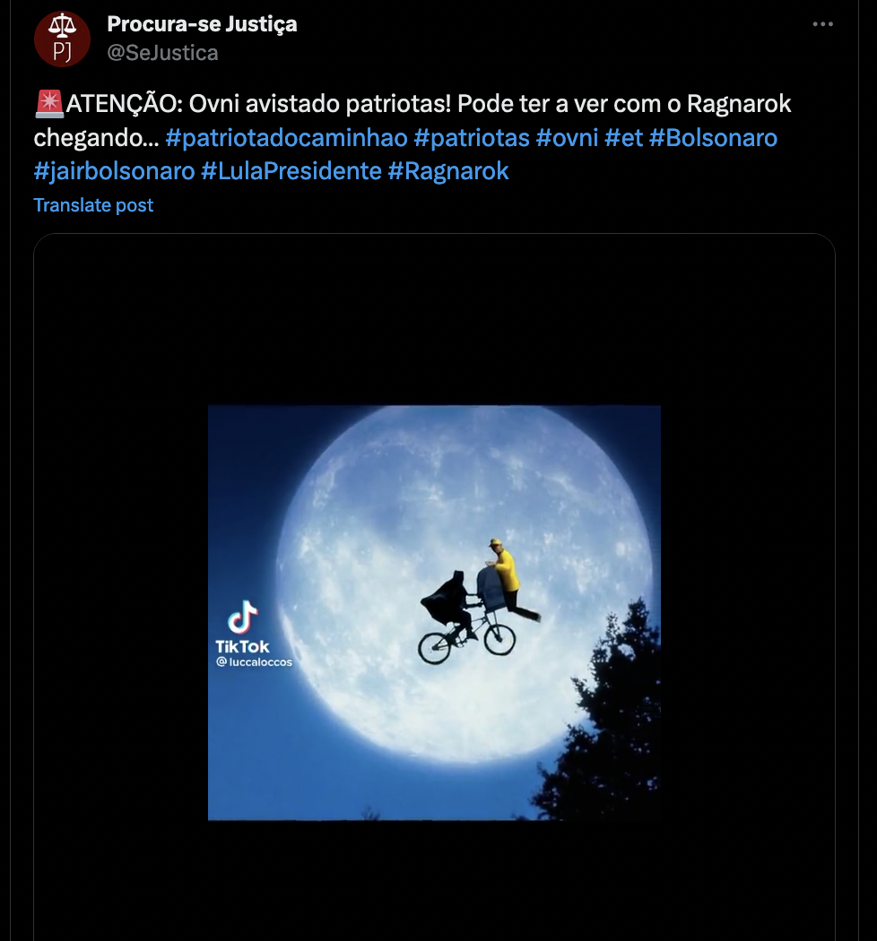

Figure 4: Example of pastiche using cinematic tropes with the ‘Truck Patriot’ or UFO clinging onto E.T.’s bicycle. Source: @SeJustica, Twitter post, 7 November 2022.[30]

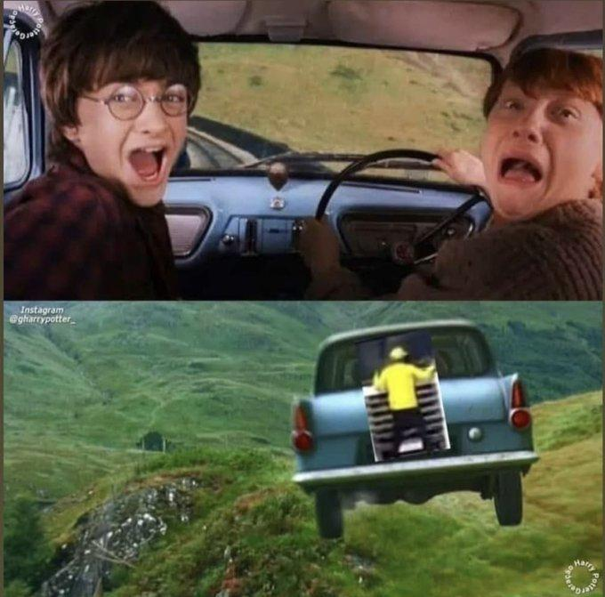

Figure 5: The ‘Truck Patriot’ mashup and a scene from *Harry Potter and the Chamber of Secrets* (2002). Source: Instagram @gharrypotter_.

In the field of audiovisual production, *Netflix Brasil* posted a video collage that combined the Truck Patriot's video footage with iconic scenes in famous Hollywood productions.[31] The figure of the Patriot is inserted into action scenes from movies such as *Spider-Man*, E.T., (Figure 4) *Harry Potter (Figure 5)*, *Nightmare on Elm Street, Priscilla, Queen of the Desert, Mad Max,* and *others*, or he appears in cartoon vignettes like *The Road Runner*. There are also iterations that reference classic moments in film history, such as a scene in which the Truck Patriot is seen clinging to a train in one of the earliest films by the Lumière Brothers, *Arrival of a Train at La Ciotat* (1895) playfully renamed by commenters as *Arrival of a Train ‘with a Patriot’ at La Ciotat*.[32]

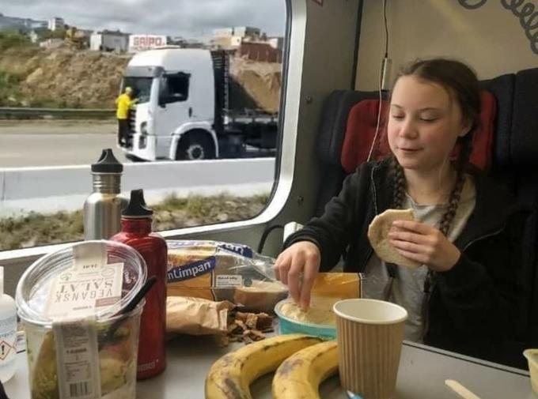

Figure 6: The Truck Patriot seen outside Greta Thunberg’s train window. Source: unknown.

Regarding music and popular culture, at times the meme is reconfigured in visual and auditory mashups with soundtracks added to the original video clip (Figure 2) with songs such as Miley Cyrus' 'Fly on the Wall' or Gloria Gaynor's 'I Will Survive’.[33] There are also iterations using iconic images like The Beatles’ iconic *Abbey Road* album cover (Figure 10). The ‘Truck Patriot’ meme also merged with an array of imagery of national and international celebrities, as in the image where the ‘Patriot’ can be sighted outside climate activist Greta Thunberg’s train window (Figure 6), where she seems to be blissfully ignoring what is happening outside. Her character serves as a symbol for all progressive-minded people whose causes and beliefs had been systematically denied by Bolsonarist ideology, such as climate change.

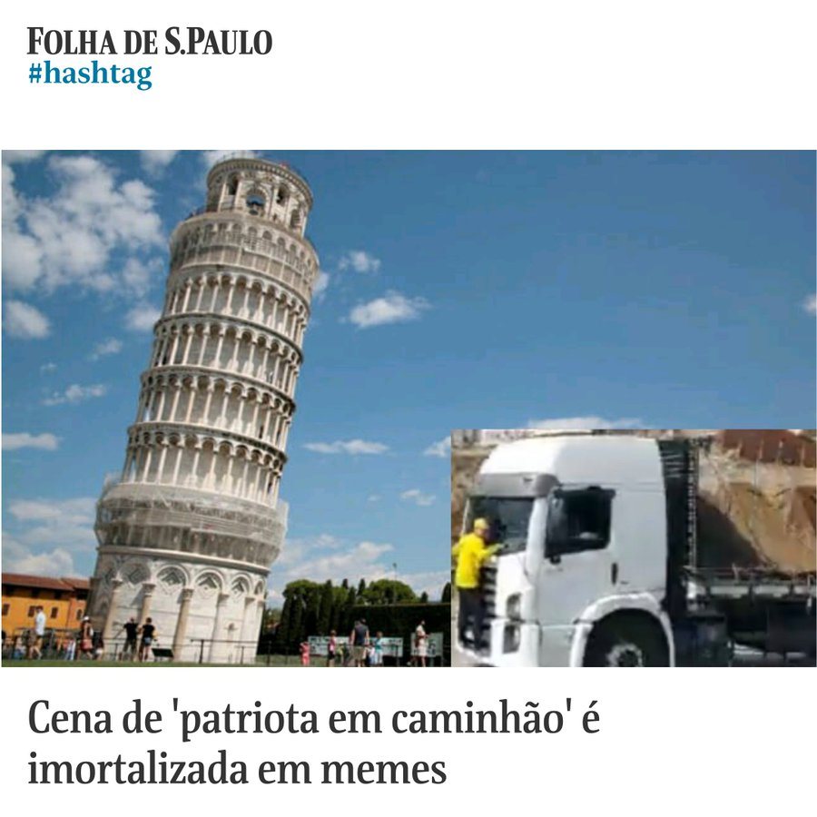

Figure 7: The Truck Patriot is seen in front of the Tower of Pisa. Source: @folha.[34]

In another series, we observe multiple mashups in an extensive series of over 200 memes depicting the ‘Truck Patriot’ traveling by truck around the world, spotted in cities across Brazil and in iconic landscapes and global monuments in the whole world, such as the pyramids of Egypt, the Taj Mahal, the Eiffel Tower and the Tower of Pisa (Figure 7). The ‘Truck Patriot’ can also be seen in outer space, either plummeting off the edge of the Flat Earth – a denialist theory defended by Bolsonarism (Figure 8) – or floating in outer space, on the Moon, or clinging to a rocket on the way to Planet Mars.



Figure 8: The Truck Patriot falling off the edge of the Flat Earth. Source: @Drifez_original, ‘E vamos de patriota do caminhão chegando a borda da terra plana’, Twitter post.[35]

The meme also surfaced on more commercially oriented images, products, and ads. Within the realm of play, the iconic figure of the ‘Truck Patriot’ was incorporated into video game interfaces like *Adventure Quest 3*,[36] or became toys as in the ‘Patriot Lego’ set. Other sets of toys and thematic paraphernalia like pens, mugs, and T-shirts appeared either as spoof ads or as items for sale on several e-commerce websites. Another unusual appropriation is the insertion of the Truck Patriot's image in advertisements and promotions on small business profiles on Instagram. Here, the Truck Patriot served as a promotional figure to sell a product or service, and the meme functions as a form of co-branding where the image's virality is used to draw attention both to the business and the political humor. Another genre of meme involves social media users sharing their reactions while scrolling through their social media feeds and looking at the memes, thereby reinforcing the viral effect of networked laughter circulating among various audiences beyond the original visual artifact.

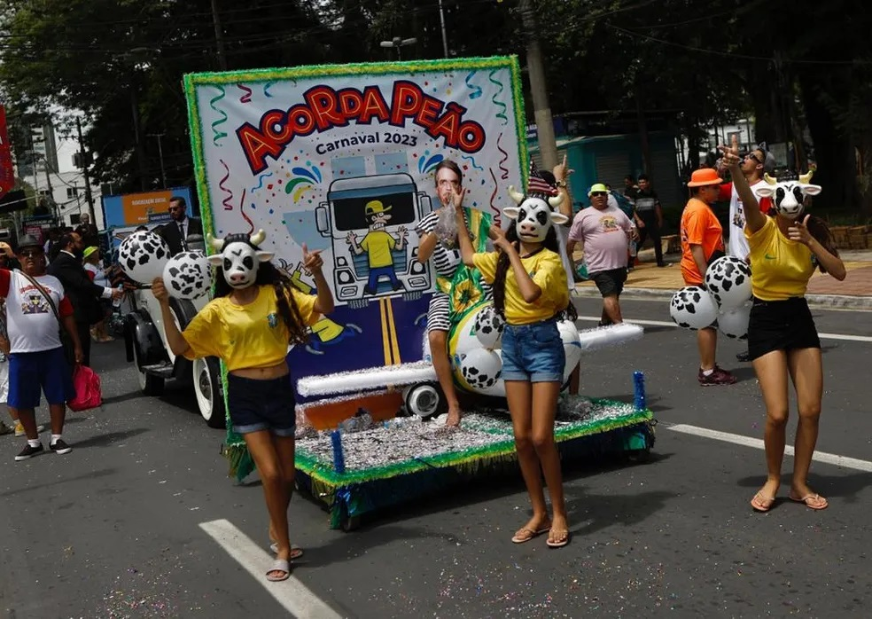

Figure 9: The 'Truck Patriot' in a carnival theme. In the background we see a carnival float representing a truck with a caricature of the Truck Patriot, and in the foreground are carnival goers dressed up as ‘patriots’ with yellow football jerseys and a cow mask, symbolizing cattle, as Bolsonarists are referred to collectively by anti-Bolsonaro supporters.

The meme also traveled beyond the internet. In the visual arts, the use of the ‘Truck Patriot’ image as a cultural icon in public art like graffiti and mural paintings spread across the streets of Brazil. One of the most spectacular uses of Truck Patriot videos was as projections in musical performances just three days after the meme first emerged.[37] The meme saw a peak in postings immediately after the election but remained active in various communication streams in the following months,[38] spanning the government transition on January 1, 2023, the Planalto Riots on January 8, and into the carnival season in March 2023 - a time when Brazilian carnival goers typically express a wide range of political opinions through music, dance, and costumes. Thus, it was not surprising that the figure of the Truck Patriot was appropriated as a central theme in various carnival costumes (Figure 9). The carnival catharsis was particularly significant because the country's largest popular festival had faced rampant criticism from the Bolsonaro government in previous years for being hedonist and sinful, and it was also the first carnival after the COVID-19 pandemic, during which street parties had been suspended due to lockdowns and social distancing measures.

As we have seen, memes are produced through the creative and performative activity of various social actors who apprehend specific discursive units by editing, reconfiguring, reframing, reassembling, and then putting them into circulation.

## Memetization as a Form of Political Participation

The concept of *interdiscursivity* is central to a communicational approach to the phenomenon of memetization both in how memes are constituted and how they become part of communication processes in this period of political transformation.[39] Memetization is a symbolic praxis of memes embedded in social networks that materializes as a visual-discursive phenomenon, whose multiple manifestations may become a form of popular culture, media activism, or political propaganda. Memes are understood through a sense-making activity grounded in interdiscursive operations, in such a way that ‘the structure of discourses is always an interdiscursive phenomenon’.[40] According to the Argentine semiotician Eliseo Verón, *interdiscursivity* is one of the constituent conditions of the functioning of social discourses. In this context, we understand that memes generate humor that serves to generate laughter as an effect of meaning because, as Verón reminds us, a discourse always generates a field of effects and never a single effect due to its non-linearity and the constitutive dissonances between production and recognition.[41]

According to Shifman, when internet users create or consume political memes, they engage in a ‘normative debate about how the world should (or should not) be and the best way to achieve that vision’. The circulation of memes and their various discursive constructs also express struggle and resistance as poetic and humorous devices used in political contexts where the meme activates ‘public discourses [that] are socially constructed, and memetic variations represent different voices and perspectives’.[42] Therefore, memes expand the range of political participation modalities by offering new, playful, and accessible modes of participation for expressing political opinions and engaging in debates on current issues. Therefore, we focus on this interdiscursive dynamic to show how social actors, mostly anonymous, appropriate discursive fragments from the social fabric, construct different ways of expressing - through humor - that it is necessary to resist and fight against Bolsonarism. In this case, the 'Truck Patriot' meme phenomenon is unique because it is efficient as a political tool for critique and ridicule of Bolsonarist fanaticism, and as a way of mobilization against extremist tendencies towards a more plural internet.

The ‘Truck Patriot’ meme can be also considered as a cultural phenomenon that creates new genres within meme typologies. It becomes a kind of memetic activism, or activism through memes, where memes travel from screens to the streets and highways and back again (Figure 9). In Gisele Beiguelman’s view, in this process, the interdiscursive phenomenon that crosses over between digital screen-based mediums and analog street-based mediums opens up to multiple derivations that break with systems of representation and their mechanisms of symbolic organization in both content and form.[43] Lastly, some 'Truck Patriot' memes also incorporate other discourses, information, and political events as elements of commentary and critique, such as the pandemic and fake news occurring during the election period or in politics in general. We notice, for instance, a process of meta-mimesis when it appropriates other internet genres such as parodies of fake news.[44]

In these interdiscursive contexts, the 'Truck Patriot' figure takes on multiple roles, first as the protagonist, but also as an interdiscursive device through its role as a double symbol for both democracy and Bolsonarism, as a supporting character in other memes, as an agent of political transformation, and as a strategy for resistance.

#### The ‘Truck Patriot’ meme as a Symbol of Democracy

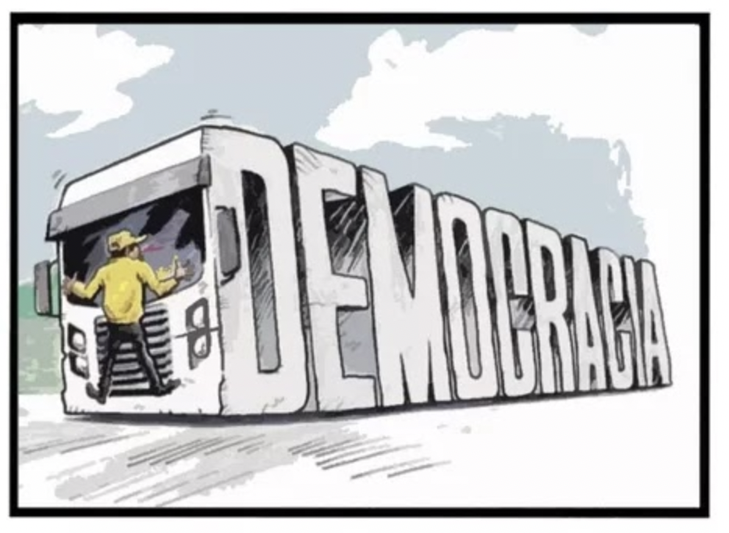

Figura 7: A political cartoon in which the 'truck' of democracy drives Bolsonarism off the road. Unknown source.

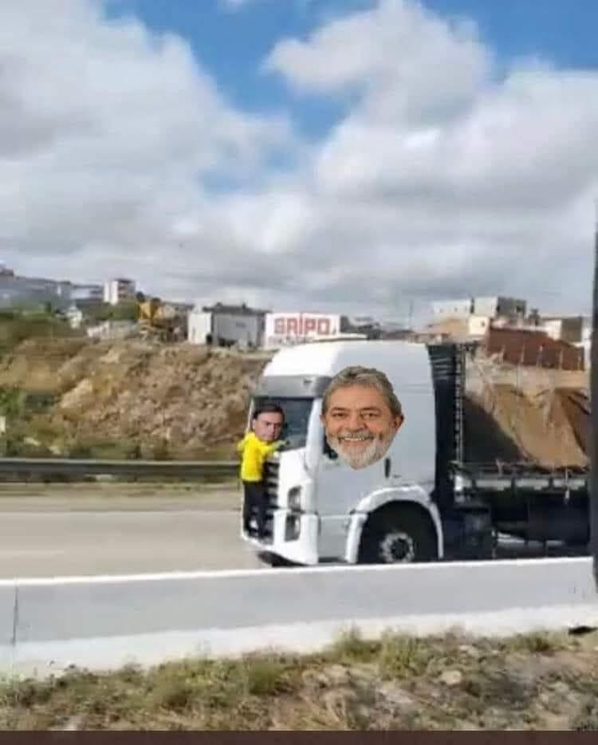

Figure 8: A collage with the Lula’s and Bolsonaro’s cut-out photographs on the original video footage. Source: #*MUSEUdeMEMES*.[45]

When memes cross over to the language of political cartoons, they become part of the political commentary and *memetize* political discourse. Here, the meme’s main visual elements of the truck, on one hand, and the Patriot figure, on the other, each acquire opposite meanings. In Figure 7, in a political cartoon the truck becomes a symbol of a strong democracy on the way to ‘crush’ the fragile symbol of Bolsonarism clinging to whatever is left of its anti-democratic values. In Figure 8, the scene is personified by a cut-out of Lula’s campaign photo as a smiling truck driver, while a desperate Jair Bolsonaro trying to hold on to the power he just lost. Both images embody the ‘aesthetic of a failed coup’[46] and the need to get rid of Bolsonaro from the political scene. This becomes especially funny when we know that Bolsonaro refuses to acknowledge Lula’s victory and ‘clings’ to power through his most committed followers.

#### The ‘Truck Patriot’ Meme as a Supporting Character

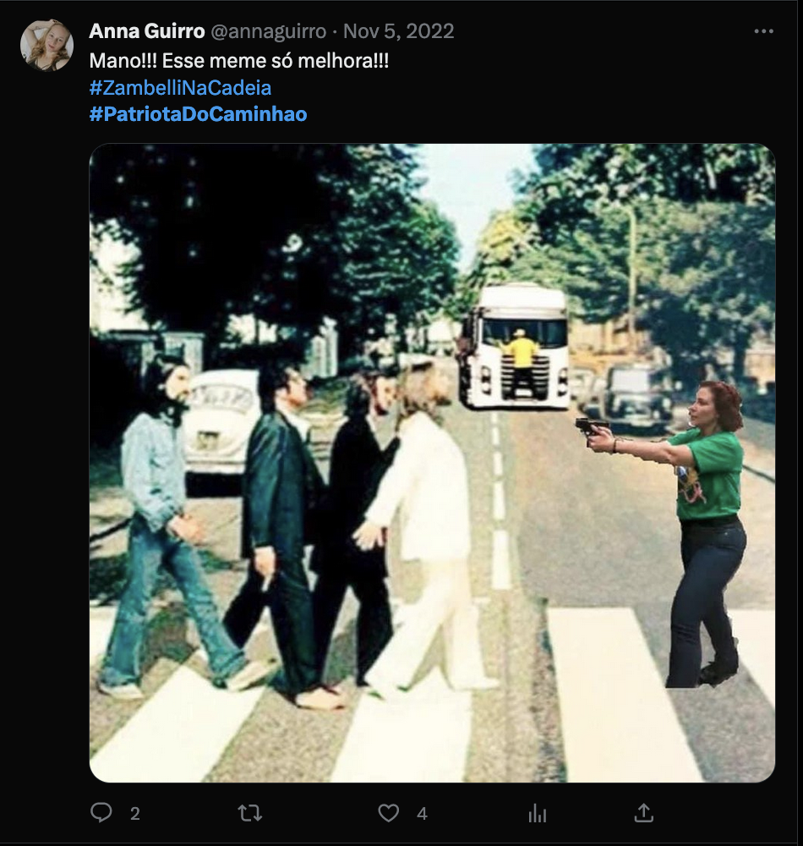

Figure 9: Zambelli’s *Abbey Road* meme with the Truck Patriot in the background. The caption reads, ‘Bro!!! This meme only gets better!!!’.Source: @annaguirro, Twitter post 5 November 2022.[47]

While the ‘Truck Patriot’ meme circulated mostly as a standalone meme, in some instances, it was combined with memes with absurd scenes from the last days of the presidential campaign. In Figure 8, the Truck Patriot becomes a supporting character in a scene that symbolizes Bolsonarist anti-democratic, violent, and criminal behaviors. The woman in the foreground is Congresswoman Carla Zambelli,[48] one of Bolsonaro's main political allies, caught on video pointing a gun to a Black journalist and Lula campaigner on the eve of election day, October 29, 2022, in a busy street in São Paulo.[49] Besides political and racially motivated violence, the incident gained significant media attention because Brazilian law forbids the use of firearms by civilians 24 hours before and after election day. Several witnesses captured images of the Congresswoman and her armed assistants publicly committing a serious electoral offense. Videos show Zambelli's confrontation with the black journalist, then chasing him, and finally pointing her gun inside a bar.[50] A flurry of memes took over social media platforms during the entire election weekend, and, when the 'Truck Patriot' meme appeared a few days later, it was immediately added on to Zambelli’s memes. In Figure 9, Zambelli’s green-clad figure holding a gun is pasted onto The Beatles’ iconic album cover *Abbey Road*, pointing her gun at John Lennon, a well-known pacifist killed by gunshot in 1980, protecting his bandmates on the crosswalk. The ‘Truck Patriot’s frontal shot is pasted in the back coming at full speed in Zambelli’s direction.

Zambelli's figure represents the symbolic and real violence associated with the militaristic and nationalist ideals of Bolsonarism, while the frightened ‘Truck Patriot’ figure in yellow, carried by the 'democracy truck', symbolizes Bolsonaro's defeat. Furthermore, we understand that although the Truck Patriot is a minor character in pictorial terms as it is seen in the background, it will soon crush Zambelli in the foreground. When combined, these two absurd scenes represent how the Bolsonarist movement tends to turn against itself without the need for the opposition to take on the task. Moreover, the meme expresses a type of humor that not only serves as an easy laugh but also reflects deeper sentiments, perhaps a kind of 'democratic revenge' and the desire of many Brazilians to expel Bolsonarism and 'run over' its leadership and allies.

#### The Truck Patriot as an Agent of Political Transformation

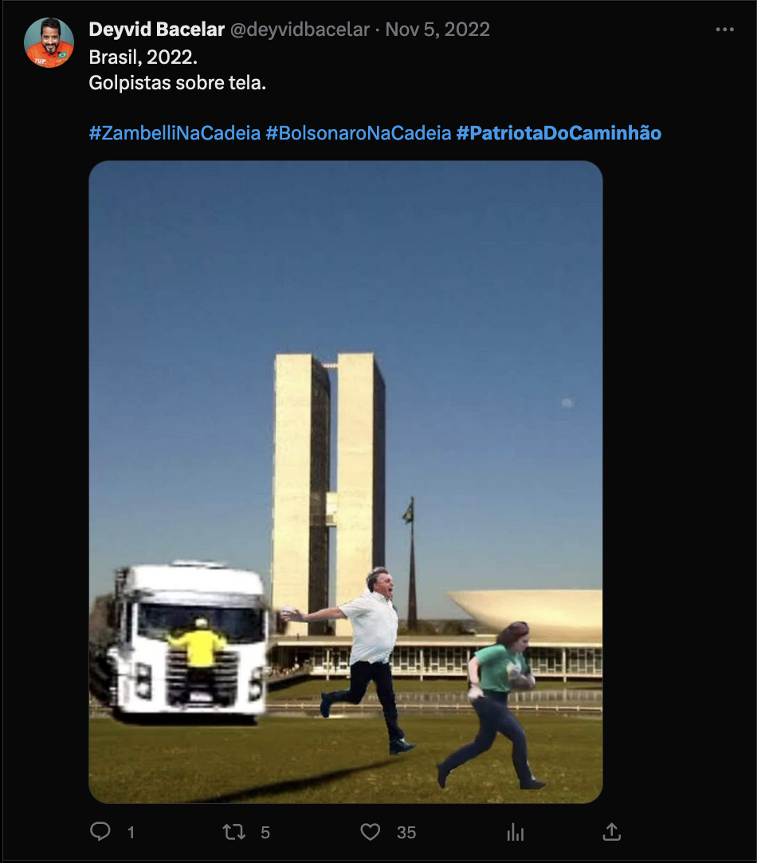

Figure 10: Photo collage of the National Congress in Brasília, where the 'Truck Patriot' is depicted on a collision course with Jair Bolsonaro and Carla Zambelli. The caption reads ‘Brazil, 2022. Rioters on panel.’, in the style of image captions given to artworks. Credit: @deyvidbacelar.[51]

Another meme shows Carla Zambelli running with a gun, followed by Jair Bolsonaro and the ‘Truck Patriot’ frozen in motion in what looks like a still shot of an action scene. They seem to be running off in desperation out of the frame as if being chased away from power for their political misconduct. The scene is set against the background of the Brazilian Congress in Brasilia, the same site of the insurrection that would take place two months later, on January 8, 2023. Using the typical meme ‘deep-fried’ aesthetic of quick, low-quality collage style, the fragments gathered from different sources are cut out from their original contexts and pasted together to generate new interdiscursivities and resignifications. In Figure 10, the caption describes the image as a work of art, ‘Brazil, 2022. Rioters on panel’ as a kind of ‘ironic sublime’ that underscores the picturesque quality of the scene. Moreover, the caricatural quality of all three figures enhances the scene’s comic effect, aiming to demoralize Bolsonaro and oust Bolsonarist politicians in general. In addition, the scene gives a sense of collective catharsis and the pursuit of justice against political figures considered to be criminals by their opponents. The ‘Truck Patriot’ here represents how Bolsonarist’s tactics have turned against themselves. The dissident truck represents force making the politicians run away, and help transform the political situation. The meme also expresses a desire for Brasilia to become inhabited by a new president and a government that respects the rights of Brazilians and their democratic institutions.

#### The ‘Truck Patriot’ meme as Meme-activist Resistance

Following Lula's democratic victory, producing and circulating the ‘Truck Patriot’ meme became an act of resistance strategy to attempt to reverse the 'culture war' that Bolsonarists had declared against all their opponents in previous years. Since the left had been on the defensive for four years, it now could regain an upper hand by exposing the ridiculousness of Bolsonarists while reinforcing bonds of solidarity. This practice had earlier been observed during the COVID-19 pandemic when Brazilians mobilized different discursive materials in the form of critical memes and laughter as a form of resistance against Bolsonaro's negationist stance towards the pandemic and his ineffective government.[52]

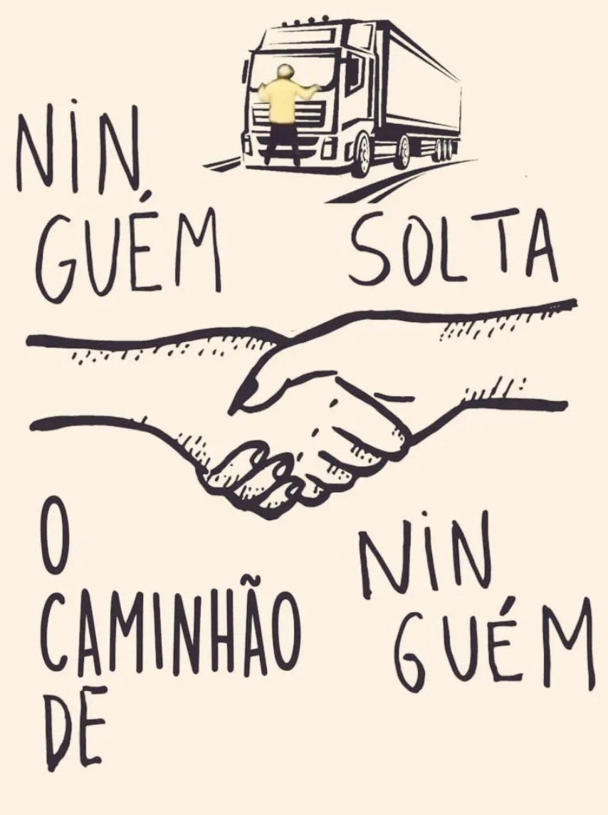

Figure 11: (left) 'Nobody lets go of anyone's hand' was a meme and slogan created during the 2018 election, inspired by collectivist and intersectional ideals symbolizing the unity of the left against Bolsonarism. (right) An ironic reinterpretation adapted from the 2018 meme, this time featuring the Truck Patriot, saying ‘No one lets go from the truck’. Source: unknown.

Besides a need to celebrate Lula’s victory in the elections, the ‘Truck Patriot’ meme was important to communicate the need to stay together to confront the ongoing acts threatening democracy. The reconfiguration of an iconic meme of resistance against Bolsonaro’s victory in 2018 (Figure 11, left) was updated to reflect the ‘Truck Patriot’ meme phenomenon that characterized Bolsonaro’s defeat in 2022 (Figure 11, right). In both images, the image of joined hands remains, yet the pictorial element and the words are changed to signify the success of the critical voice of the resistance against Bolsonarism. Using self-parody, the rose is replaced with a drawing of the truck with the Patriot, and the word ‘hand’ is replaced by the word for ‘truck’. But in the second image, the hands and the words are doing different things. If in the first image, ‘ no one lets go of anyone’s hand’ means ‘we stick together, no matter what’, in the second there is an ironic reversal where the words say ‘no one lets go of the truck’ where ‘no one’ means that the Bolsonaristas clinging to their illusions. A new discursive unity is thus created through the replication of some verbal elements and the substitution of iconography as a one-liner joke that proposes a reversal of meanings.

This self-appropriative gesture suggests the continuity of memetic activism that reinforces bonds of unity and solidarity, needed to demarcate a discursive territory of humor as a form of ideological and media superiority over the opposing side. If, during Bolsonaro’s extreme-right government memes were used by right-wingers for political propaganda, the left reacted by using memes to express resistance. The ‘Truck Patriot’ meme became an essential discursive device for the left to express itself not only against the anti-democratic acts in front of the barracks but especially to articulate strategies to combat ongoing threats of coup attempts and military interventions.

## Conclusion

The memetization of the man clinging to the truck indicates two codependent movements. While the left's humor and meme creativity promoted a sense of relief and emancipation from Bolsonarism's dominance on social media and in the cultural imaginary, it also fueled a growing resentment and anger among Bolsonarists, as their protests escalated into various anti-democratic actions in the post-election period. Nonetheless, from the left's perspective, the strengthening of its oppositional voice immediately after the election was empowered by a ‘memetic turn’ with the help of the ‘Truck Patriot’ memes. It gave the winning majority a possibility to take back media space and discourses that had been suppressed during the Bolsonaro government and its fake news machinery. The Truck Patriot meme also became a cathartic collective online celebration of Lula's victory over Bolsonaro and empowered the new majority, making Brazilians able to laugh openly and collectively again, following cultural tropes and the central role of humor in the Brazilian psyche.

Despite the broad popular struggle of the left and the imaginative expressions of the ‘Truck Patriot’ meme, it did not deter the continuation of Bolsonarist anti-democratic tactics. In fact, the ‘Truck Patriot’ meme was co-opted by Bolsonarists to exalt the symbolic figure of the ‘Patriot’, as seen in new profiles or renaming old accounts on Twitter with variations of '@patriotadocaminhao' which elevated the yellow-clad patriot figure as a heroic symbol of far-right mobilizations. Indeed, in the following months, Bolsonarists continued their practices of disseminating false messages on social media and messaging apps demanding a military intervention. By targeting specific groups on WhatsApp and Telegram specifically in strategic sectors such as agribusiness and the cargo transportation sector, which includes thousands of truck drivers and powerful financiers, they were able to mobilize protesters toward what eventually resulted in the Planalto Riots on January 8, 2023. Nonetheless, the ‘Truck Patriot’ remains a symbol of the inventiveness of the Brazilian internet and the new social imaginary created during a turbulent period in Brazilian political history signifying the power shift from an anti-democratic to a democratic government with Lula’s victory.

## Bibliography

@AndreJanonesAdv, Twitter profile.

@annaguirro, ‘Mano!!! Esse meme só melhora!!!#ZambelliNaCadeia #PatriotaDoCaminhao’, Twitter post, 5 November, 2022, 3:11 AM, https://twitter.com/annaguirro/status/1588715480969535489.

‘Bolsonaristas se reuniram em atos antidemocráticos em 24 estados e no DF’, G1, 3 November 2022, https://g1.globo.com/politica/eleicoes/2022/noticia/2022/11/02/atos-bolsonaristas-quarteis-brasil.ghtml.

Beiguelman, Giselle. Políticas da Imagem: Vigilância e Resistência na Dadosfera. São Paulo: Ubu Editora, 2021.

Borelli, Viviane, and Regiani, Herivelto. ‘Memetizing and Mediatizing: Memes as an Evangelical Discursive Strategy’. ESSACHESS - Journal for Communication Studies, 10.2 (2017): 9–31.

______, Dalmolin, Aline, Feliciano, M.Z., and Regiani, Herivelto. ‘O Riso como Resistência: Memes contra Bolsonaro no Contexto da Pandemia’, in *Anais do 44º Congresso brasileiro de ciências da comunicação* *INTERCOM*, Recife, Brasil, 2021: 1-15, https://www.portalintercom.org.br/anais/nacional2021/resumos/dt8-ci/herivelton-regiani.pdf.

Bolada, Dandara. ‘O Patriota do Caminhão’,#*MUSEUdeMEMES*, 2022, https://museudememes.com.br/collection/patriota-do-caminhao.

‘Bora Bill, Scooby travando, patriota do caminhão: relembre memes de 2022 que fizeram o Brasil sorrir’, G1, 15 December 2022, https://gshow.globo.com/tudo-mais/viralizou/noticia/relembre-os-memes-que-movimentaram-as-redes-sociais-em-2022.ghtml.

Brito, Fernando. ‘Desova de Bolsonaro começa e já vai ao ridículo’, *Tijolaço*, 5 November 2022, https://tijolaco.net/desova-de-bolsonaro-comeca-e-ja-vai-ao-ridiculo/.

Braga, José Luiz. ‘Dispositivos interacionais; Circuitos de Comunicação’, in José Luiz Braga e R. Calazans (eds.), *Matrizes Interacionais: A Comunicação Constrói a Sociedade*, Campina Grande: EDUEPB, Vol. 2, 2017, pp. 15–64.

Calgaro, Fernando. ‘Bloqueios bolsonaristas: quais são as penas previstas para interdição de rodovias’, *G1*, 1 November 2022, https://g1.globo.com/politica/eleicoes/noticia/2022/11/01/bloqueios-bolsonaristas-quais-sao-as-penas-previstas-para-interdicao-de-rodovias.ghtml.

‘Cena de ‘patriota em caminhão’ em memes’, @folha Twitter post, 4 November 2022, 11:20PM, https://twitter.com/folha/status/1588657529210507265.

@deyvidbacelar., ‘Brasil, 2022. Golpistas sobre tela’, Twitter post, 5 November 2022, 1:21 AM, https://twitter.com/deyvidbacelar/status/1588687985758781440.

DCM TV, ‘Bolsonarista fica pendurado em para-brisa de caminhão que furou bloqueio golpista’, *DCM TV*, YouTube video, 1:33, 3 November 2022,

https://www.youtube.com/watch?v=qmIGA9r455w.

‘Do patriota do caminhão à tapioca homofóbica: relembre os memes de 2022’, Folha de S. Paulo, 15 December 2022, https://www1.folha.uol.com.br/blogs/hashtag/2022/12/do-patriota-do-caminhao-a-tapioca-homofobica-relembre-os-memes-de-2022.shtml.

Domingos, Roney. ‘É fake que 51 milhões de votos foram roubados de Bolsonaro’, *G1*,

1 November 2022.

https://g1.globo.com/fato-ou-fake/eleicoes/noticia/2022/11/07/e-fake-que-51-mihoes-de-votos-foram-roubados-de-bolsonaro.ghtml.

@Drifez_original, ‘E vamos de patriota do caminhão chegando a borda da terra plana’, Twitter post, 6 November 2022, 11:12 AM, https://twitter.com/Drifez_original/status/1589199155347755013.

‘É fake que 51 milhões de votos foram roubados de Bolsonaro’, G1, 1 November 2022, https://g1.globo.com/fato-ou-fake/eleicoes/noticia/2022/11/07/e-fake-que-51-mihoes-de-votos-foram-roubados-de-bolsonaro.ghtml.

@felipeneto, Twitter profile.

@felipeneto, ‘Edição urgente do BIP! Conseguimos atualizações sobre o Patriota do Caminhão... Compartilhe.’, Twitter post, 4 November 2022, 11:20 AM, https://twitter.com/i/status/1588657456137355266.

G1, ‘Bolsonaristas se reuniram em atos antidemocráticos em 24 estados e no DF’, *G1*,

2 November, 2022, https://g1.globo.com/politica/eleicoes/2022/noticia/2022/11/02/atos-bolsonaristas-quarteis-brasil.ghtml.

‘Governo Bolsonaro liberou em média 619 novas armas por dia para CACs: 57% dos registros foram em 2022’, G1, 19 January 2023, https://g1.globo.com/politica/noticia/2023/01/19/governo-bolsonaro-liberou-em-media-619-novas-armas-por-dia-para-cacs-47percent-dos-registros-foram-em-2022.ghtml.

Gonçalves, Andre Luiz Dias. ’WhatsApp é o app mais popular do Brasil; veja o top 10’, Tecmundo, 8 January 2022, https://www.tecmundo.com.br/dispositivos-moveis/231633-whatsapp-app-popular-brasil-veja-o-top-10.htm.

Horbyk, Roman, Löfgren, Isabel, Soriano, Cheryl, and Prymashenko,Yana. ‘Fake News as Meta-mimesis: Imitative Genres and Storytelling in the Philippines, Brazil, Russia and Ukraine’, *Popular Inquiry – The Journal of the Aesthetics of Kitsch, Camp and Mass Culture* 8 (2021).

@joaorzc, ‘Desculpa chegar atrasado pro meme do patriota, gente. É que eu vim de trem. "L'Arrivée d'un patriote en gare de La Ciotat". Irmãos Lumière, 1985.’, Twitter post, 9 November, 2022, 9:22 AM, https://twitter.com/joaorzc/status/1590394436814413824.

Lacombe, Milly. ‘O patriota do caminhão é a estética de um golpe fracassado’, *Uol*, 4 November 2022, UoLhttps://www.uol.com.br/esporte/colunas/milly-lacombe/2022/11/04/o-patriota-preso-ao-caminhao-e-a-estetica-de-um-golpe-fracassado.htm.

Löfgren, Isabel. ‘Memes as means of public dissent and cultural resistance in the post-electoral period in Brazil’, Urgent Publishing, Institute of Network Cultures, Arnhem, Holland, 19 May 2019, https://vimeo.com/345459399.

–––––––. ‘Semiotics of Care and Violence: Memetization and Necropolitics during the Brazilian 2018 Elections and the action #MarielleMultiplica’, in Chloë Arkenbout and Laurence Sherz (eds), *Critical Meme Reader 2: Memetic Tacticality*, Amsterdam: Institute of Network Cultures, 2022, pp. 52-75.

Lima, Mateus. ‘Patriota do Caminhão/Truck’s Patriot: part of a series on 2022 Brazilian General Election’, *Know Your Meme*, 10 December 2022, https://knowyourmeme.com/memes/patriota-do-caminhao-trucks-patriot.

Monitor de Whatsapp, http://www.monitor-de-whatsapp.dcc.ufmg.br/.

@Mayhem_AQ3D, ‘He passed by me too’, Twitter post, 9 November 2022, 7:01PM, https://twitter.com/Mayhem_AQ3D/status/1590404137707270144.

@NetflixBrasil, ‘Pensando muito nessa cena.’, Twitter post, 3 November 2022, 9:17 PM, <https://twitter.com/i/status/1588264095580651520>.

Paiva, Fernado. *Panorama Mobile*

*Time/Opinion Box - Usos de Apps no Brasil*, MobileTime/Opinion Box, 2022, file:///home/araxa/Downloads/Panorama_APPS-DEZ22-OK.pdf.

Pires, Breno. ‘O show de Jair – Como o PT enfrentou a milícia digital bolsonarista’, *Revista Piauí* 195 (December 2022): 24-28.

Propp, Vladimir. *Comicidade e Riso*, Trad. Aurora Fornoni Bernardini e Homero Freitas de Andrade, São Paulo: Editora Ática, 1976.

Queiroz, Eça de. *AS FARPAS: crônica mensal da política, das letras e dos costumes*. Lisboa: Tipografia Universal, 1872, http://purl.pt/256/4/.

Resende, Sara, Vinícius Cassela and José Vianna. ‘Atos golpistas: o que a Abin rastreou sobre financiadores e novas tentativas de ataques’, *G1*, 20 July 2023, https://g1.globo.com/politica/noticia/2023/07/20/atos-golpistas-o-que-a-abin-rastreou-sobre-financiadores-e-novas-tentativas-de-ataques.ghtml.

Sapio, Marcello e Adriana De Luca. ‘Especialistas analisam legalidade de manifestações bolsonaristas’, CNN Brasil, 2 November 2022, https://www.cnnbrasil.com.br/politica/especialistas-analisam-legalidade-de-manifestacoes-bolsonaristas/.

@SeJustica, ‘ATENÇÃO: Ovni avistado patriotas! Pode ter a ver com o Ragnarok chegando…#patriotadocaminhao #patriotas #ovni #et #Bolsonaro #jairbolsonaro #LulaPresidente #Ragnarok’, Twitter post, 7 November 2022, 2:39 AM, https://twitter.com/SeJustica/status/1589432382700277762.

Shifman, Limor. *Memes in Digital Culture*, Cambridge: The MIT Press, 2014.

Stabile, Arthur. ‘Governo Bolsonaro liberou em média 619 novas armas por dia para CACs: 57% dos registros foram em 2022’, *G1*, 19 January 2023,

https://g1.globo.com/politica/noticia/2023/01/19/governo-bolsonaro-liberou-em-media-619-novas-armas-por-dia-para-cacs-47percent-dos-registros-foram-em-2022.ghtml.

UOL, ‘Pronunciamento de Bolsonaro: veja o discurso completo do presidente após derrota nas eleições’, YouTube video, 2:28, 1 November 2022, https://www.youtube.com/watch?v=2Ywjzf88oWY.

UOL,‘Vídeo flagra homem preso a caminhão após veículo furar bloqueio’, UOL, YouTube video, 1:30, 3 November 2022, https://www.youtube.com/watch?v=qmIGA9r455w.

Verón, Eliseo. *Fragmentos de um tecido*. São Leopoldo: Unisinos, 2004.

Teodoro, Plinio, ‘Vídeo: bolsonarista do caminhão vira cenário para Primavera Sound’. *Revista Fórum*, 6 November 2022, https://revistaforum.com.br/cultura/2022/11/6/video-bolsonarista-do-caminho-vira-cenario-para-primavera-sound-126045.html.

Wikipedia contributors, ‘Patriota do Caminhão’, 15 November 2022, https://pt.wikipedia.org/wiki/Patriota_do_caminh%C3%A3o, accessed 10 October, 2023.

1. Associate Professor in the Graduate Program in Communication Sciences at the Federal University of Santa Maria (UFSM), Brazil. Email: viviane.borelli@ufsm.br.
2. Senior lecturer in Media and Communications at Södertörn University, Sweden. Email: isabel.lofgren@sh.se.
3. Eça de Queiroz, *AS FARPAS: crônica mensal da politica, das letras e dos costume*s. Lisboa: Tipografia Universal, fevereiro de 1872, http://purl.pt/256/4/.
4. These 72 hours were repeatedly postponed in the following months, keeping the expectations of the protesters alive until the attempted coup on January 8, 2023.
5. In late May 2023, the parliamentary investigation commission of coup-related acts (CPI dos atos golpistas) released documents that reveal the names of those who financed the coup attempt. See Sara Resende, Vinícius Cassela and José Vianna, ‘Atos golpistas: o que a Abin rastreou sobre financiadores e novas tentativas de ataques’, *G1*, 20 July 2023, https://g1.globo.com/politica/noticia/2023/07/20/atos-golpistas-o-que-a-abin-rastreou-sobre-financiadores-e-novas-tentativas-de-ataques.ghtml.
6. UOL, ‘Pronunciamento de Bolsonaro: veja o discurso completo do presidente após derrota nas eleições’, YouTube video, 2:28, 1 November 2022, https://www.youtube.com/watch?v=2Ywjzf88oWY.
7. Isabel Löfgren, *Memes as means of public dissent and cultural resistance in the post-electoral period in Brazil*,Urgent Publishing, Institute of Network Cultures, Arnhem, Holland, 19 May 2019. https://vimeo.com/345459399.
8. Breno Pires, ‘O show de Jair – Como o PT enfrentou a milícia digital bolsonarista’, *Revista Piauí* Vol. 195, (Dezembro 2022): 24–28.
9. @AndreJanonesAdv, Twitter profile; @felipeneto, Twitter profile.
10. Pires, ‘O show de Jair’, p. 26.
11. On the day of Bolsonaro’s reappearance, *G1,* the largest online news portal in Brazil owned by the Globo, fact-checked false information circulating on Telegram, WhatsApp, Facebook, Instagram, TikTok, and YouTube, such as claims of election fraud. Roney Domingos, ‘É fake que 51 milhões de votos foram roubados de Bolsonaro’, *G1*, 1 November 2022. https://g1.globo.com/fato-ou-fake/eleicoes/noticia/2022/11/07/e-fake-que-51-mihoes-de-votos-foram-roubados-de-bolsonaro.ghtml.
12. Voting in Brazil is mandatory and carried out via electronic voting stations.
13. The truckers' participation was significant since the time of the year was considered the 'off-season,' meaning that at that moment, many truck drivers who primarily transport grain had no cargo to carry. This fact is believed to have contributed to a higher level of participation from the sector in the protests against the election results and the subsequent blockades of roads across virtually the entire national territory. Another significant demonstration took place on November 15, a national holiday, when thousands of people dressed in green and yellow gathered in the streets of Brazilian state capitals. However, this time, the radicals did not have the support of the truckers, as it was necessary to resume transportation of goods on Brazilian roads.
14. The Federal Highway Police (PRF) is the government authority responsible for road management across the country. Even though the PRF stated in a press release that they were taking action against protesters, their permissive stance was immediately questioned. Marcello Sapio e Adriana De Luca, ‘Especialistas analisam legalidade de manifestações bolsonaristas’, *CNN Brasil*, 2 November 2022, https://www.cnnbrasil.com.br/politica/especialistas-analisam-legalidade-de-manifestacoes-bolsonaristas/.
15. The media published news regarding the penalties outlined for the blockades on the highways at that time. Fernando Calgaro, ‘Bloqueios bolsonaristas: quais são as penas previstas para interdição de rodovias’, *G1*, 1 November 2022, https://g1.globo.com/politica/eleicoes/noticia/2022/11/01/bloqueios-bolsonaristas-quais-sao-as-penas-previstas-para-interdicao-de-rodovias.ghtml.
16. Blockades were reported in 24 Brazilian states and the Federal District. Brazil has a total of 26 states, in addition to the Federal District. The protests on November 2, 2022, occurred in hundreds of Brazilian cities that have military bases.G1, ‘Bolsonaristas se reuniram em atos antidemocráticos em 24 estados e no DF’, *G1*, 2 November, 2022, https://g1.globo.com/politica/eleicoes/2022/noticia/2022/11/02/atos-bolsonaristas-quarteis-brasil.ghtml.
17. These actions included religious expressions (with symbols from various religious beliefs but not necessarily institutionalized) such as prayers and hymns of praise around burning tires on the roads. Later on, protesters decided to organize demonstrations in front of military barracks which often became more esoteric. Flash mobs were used to communicate ‘with the beyond’ by crowds emitting signals with mobile phone flashlights towards the sky, hoping that aliens in outer space could hear their desperate pleas for military intervention. These and many other highly performative Bolsonaro-supporting demonstrations revealed how the movement is well-organized in terms of activism, logistics, and media apparatus, but also equally absurd in terms of fanatic engagement. Monitoring conducted by Professor Fabricio Bevenuto de Souza from UFMG (Federal University of Minas Gerais) showed such movements during the elections. Universidade Federal de Minas Gerais, ‘Monitor de Whatsapp’, http://www.monitor-de-whatsapp.dcc.ufmg.br/.
18. Mateus Almeida and Marcos Noronha, ‘Bora Bill, Scooby travando, patriota do caminhão: relembre memes de 2022 que fizeram o Brasil sorrir’, Gshow, 15 December 2022, https://gshow.globo.com/tudo-mais/viralizou/noticia/relembre-os-memes-que-movimentaram-as-redes-sociais-em-2022.ghtml; and Rebeca Oliveira, ‘Do patriota do caminhão á tapioca homofóbica: relembre os memes de 2022’, Folha de S. Paulo, 23 December 2022, https://www1.folha.uol.com.br/blogs/hashtag/2022/12/do-patriota-do-caminhao-a-tapioca-homofobica-relembre-os-memes-de-2022.shtml.
19. UOL,‘Vídeo flagra homem preso a caminhão após veículo furar bloqueio’, UOL, YouTube video, 1:30, 3 November 2022, https://www.youtube.com/watch?v=qmIGA9r455w.
20. DCM TV, ‘Bolsonarista fica pendurado em para-brisa de caminhão que furou bloqueio golpista’, *DCM T*V, YouTube video, 1:33, 3 November 2022, https://www.youtube.com/watch?v=qmIGA9r455w.
21. The most popular platforms in Brazil are WhatsApp (54%), Instagram (42%), Facebook (33%), followed by Youtube, Twitter, and Telegram. Fernando Paiva, Panorama Mobile Time/Opinion Box - Usos de Apps no Brasil, MobileTime/Opinion Box, 2022, file:///home/araxa/Downloads/Panorama_APPS-DEZ22-OK.pdf; and André Luiz Dias Gonçalves,’WhatsApp é o app mais popular do Brasil; veja o top 10’, Tecmundo, 8 January 2022, https://www.tecmundo.com.br/dispositivos-moveis/231633-whatsapp-app-popular-brasil-veja-o-top-10.hmt.
22. Mateus Lima, ‘Patriota do Caminhão/Truck’s Patriot: part of a series on 2022 Brazilian General Election’, *Know Your Meme*, 10 December 2022,https://knowyourmeme.com/memes/patriota-do-caminhao-trucks-patriot.
23. @felipeneto, ‘Edição urgente do BIP! Conseguimos atualizações sobre o Patriota do Caminhão... Compartilhe.’, Twitter post, 4 de novembro de 2022, 11:20 AM, https://twitter.com/i/status/1588657456137355266.
24. The 'Truck Patriot' meme has its own entryin the #*MUSEUdeMEMES* collection, a Brazilian meme collection project developed by coLAB - Laboratory for Research in Communication, Political Cultures, and Collaborative Economics at UFF (Universidade Federal Fluminense). Dandara Bolada, ‘O Patriota do Caminhão’, #*MUSEUdeMEMES*, 2022, https://museudememes.com.br/collection/patriota-do-caminhao.
25. Wikipedia contributors, ‘Patriota do Caminhão’, 15 November 2022, https://pt.wikipedia.org/wiki/Patriota_do_caminh%C3%A3o, accessed 10 October, 2023.
26. Eliseo Verón, *La semiosis social. Fragmentos de una teoría de la discursividad*. Barcelona: Gedisa, 1996.
27. Vladimir Propp. *Comicidade e riso*, trans. Aurora Fornoni Bernardini e Homero Freitas de Andrade. São Paulo: Editora Ática, 1976.
28. In the media sensation that followed, Júnior César Peixoto gave interviews to television channels, news portals, newspapers, and magazines, stating that he was in fear for his life thinking he would die, and asked the driver to stop. However, the truck driver claimed at the time that he had stopped and asked the protester to get off, which did not happen. The media coverage also had an impact on his private life, as he became a subject of mockery: he deleted his Facebook account and made his Instagram profile private. Later on, he capitalized on the situation to become a micro-celebrity within pro-Bolsonaro circles, becoming an example of a dedicated patriot whose resilience in surviving this adventure became a symbol of sacrifice and commitment to the Bolsonaro cause.
29. Limor Shifman, *Memes in Digital Culture*, Cambridge:The MIT Press, 2014.
30. @SeJustica, ‘ATENÇÃO: Ovni avistado patriotas! Pode ter a ver com o Ragnarok chegando…#patriotadocaminhao #patriotas #ovni #et #Bolsonaro #jairbolsonaro #LulaPresidente #Ragnarok’, Twitter post, 7 November 2022, 2:39 AM, https://twitter.com/SeJustica/status/1589432382700277762.
31. @NetflixBrasil, ‘Pensando muito nessa cena.’, Twitter post, 3 November 2022, 9:17 PM, https://twitter.com/i/status/1588264095580651520.
32. @joaorzc, ‘Desculpa chegar atrasado pro meme do patriota, gente. É que eu vim de trem. "L'Arrivée d'un patriote en gare de La Ciotat". Irmãos Lumière, 1985.’, Twitter post, 9 November, 2022, 9:22 AM, https://twitter.com/joaorzc/status/1590394436814413824.
33. @NetflixBrasil, ‘Pensando muito nessa cena.’.
34. @folha, ‘Cena de ‘patriota em caminhão’ em memes’, Twitter post, 4 November 2022, 11:20PM, https://twitter.com/folha/status/1588657529210507265.
35. @Drifez_original, ‘E vamos de patriota do caminhão chegando a borda da terra plana’, Twitter post, 6 November 2022, 11:12 AM, https://twitter.com/Drifez_original/status/1589199155347755013.
36. @Mayhem_AQ3D, ‘He passed by me too’, Twitter post, 9 November 2022, 7:01PM, https://twitter.com/Mayhem_AQ3D/status/1590404137707270144.
37. Plinio Teodoro, ‘Vídeo bolsonarista do caminhão vira cenário para Primavera Sound’. *Revista Fórum*, 6 November, 2022, https://revistaforum.com.br/cultura/2022/11/6/video-bolsonarista-do-caminho-vira-cenario-para-primavera-sound-126045.html.
38. José Luiz Braga, ‘Dispositivos interacionais; Circuitos de Comunicação’, in José Luiz Braga e R. Calazans (eds.) *Matrizes Interacionais: A Comunicação Constrói a Sociedade*, vol.2, Campina Grande: EDUEPB, 2017, pp. 15-64.
39. Viviane Borelli and Herivelton Regiani, ‘Memetizing and Mediatizing: Memes as an Evangelical Discursive Strategy’. *ESSACHESS - Journal for Communication Studies* 10 (2017): 9-31, and

    Isabel Löfgren, ‘Semiotics of Care and Violence: Memetization and Necropolitics during the Brazilian 2018 Elections and the action #MarielleMultiplica’, In Chloë Arkenbout and Laurence Sherz (eds.), *Critical Meme Reader 2: Memetic Tacticality*, Amsterdam: Institute of Network Cultures, 2022, pp. 52-75
40. Eliseo Verón, *Fragmentos de um tecido*, São Leopoldo: Unisinos, 2004, p.69.
41. Verón, *Fragmentos de um tecido*, p.69.
42. Shifman, *Memes in Digital Culture*, p.8.
43. Giselle Beiguelman, *Políticas da Imagem: Vigilância e Resistência na Dadosfera*. São Paulo: Ubu Editora, 2021.
44. Roman Horbyk, Isabel Löfgren, Cheryl Soriano, and Yana Prymashenko, ‘Fake News as Meta-mimesis:

    Imitative Genres and Storytelling in the Philippines, Brazil, Russia and Ukraine’, Popular Inquiry: t*he*

    *Journal of the Aesthetics of Kitsch, Camp and Mass Culture* 8.1 (2021): 30-54.
45. Fernando Brito, ‘Desova de Bolsonaro começa e já vai ao ridículo’, Tijolaço, 5 November 2022, https://tijolaco.net/desova-de-bolsonaro-comeca-e-ja-vai-ao-ridiculo/.
46. Milly Lacombe, ‘O patriota do caminhão é a estética de um golpe fracassado’, *UOL*, 4 November 2022, UoLhttps://www.uol.com.br/esporte/colunas/milly-lacombe/2022/11/04/o-patriota-preso-ao-caminhao-e-a-estetica-de-um-golpe-fracassado.htm.
47. @annaguirro, ‘Mano!!! Esse meme só melhora!!!#ZambelliNaCadeia #PatriotaDoCaminhao’, Twitter post, 5 November 2022, 3:11 AM, https://twitter.com/annaguirro/status/1588715480969535489
48. Carla Zambelli is a Federal Deputy from the PL (Liberal Party), a party allied with Jair Bolsonaro.
49. It's important to note that, like the Congresswoman who owns three registered firearms, thousands of people celebrated the deregulation of gun ownership during the Bolsonaro government. The so-called ‘CACs’ - an acronym for ‘hunters, shooters, and collectors’ in Portuguese - started obtaining gun licenses that were never previously allowed by Brazilian legislation. According to data released in January 2023 by *G1*, a Globo news portal, between 2019 and 2022, 904,858 gun licenses were issued, or 619 new guns per day, for four years. Arthur Stabile, ‘Governo Bolsonaro liberou em média 619 novas armas por dia para CACs: 57% dos registros foram em 2022’, *G1*, 19 January 2023, https://g1.globo.com/politica/noticia/2023/01/19/governo-bolsonaro-liberou-em-media-619-novas-armas-por-dia-para-cacs-47percent-dos-registros-foram-em-2022.ghtml.
50. Even though Zambelli claims she had been initially pushed and attacked by Lula’s supporters, most of the video footage shows her running and carrying a pistol.
51. @deyvidbacelar., ‘Brasil, 2022. Golpistas sobre tela’, Twitter post, 5 November 2022, 1:21 AM, https://twitter.com/deyvidbacelar/status/1588687985758781440.
52. Viviane Borelli, Aline Dalmolin, M.Z. Feliciani, Herivelto Regiani, ‘O Riso como Resistência: Memes contra Bolsonaro no Contexto da Pandemia’, A*nais do 44º Congresso brasileiro de ciências da comunicação - INTERCOM*, Recife, Brasil, October 2021, https://www.portalintercom.org.br/anais/nacional2021/resumos/dt8-ci/herivelton-regiani.pdf.